Creating SQL Agent Jobs – Automate Backups

**Step 1:** Right click on either DatabaseBackup – USER_DATABASES – FULL, DIFF, or LOG whichever one you are doing first and select new job.

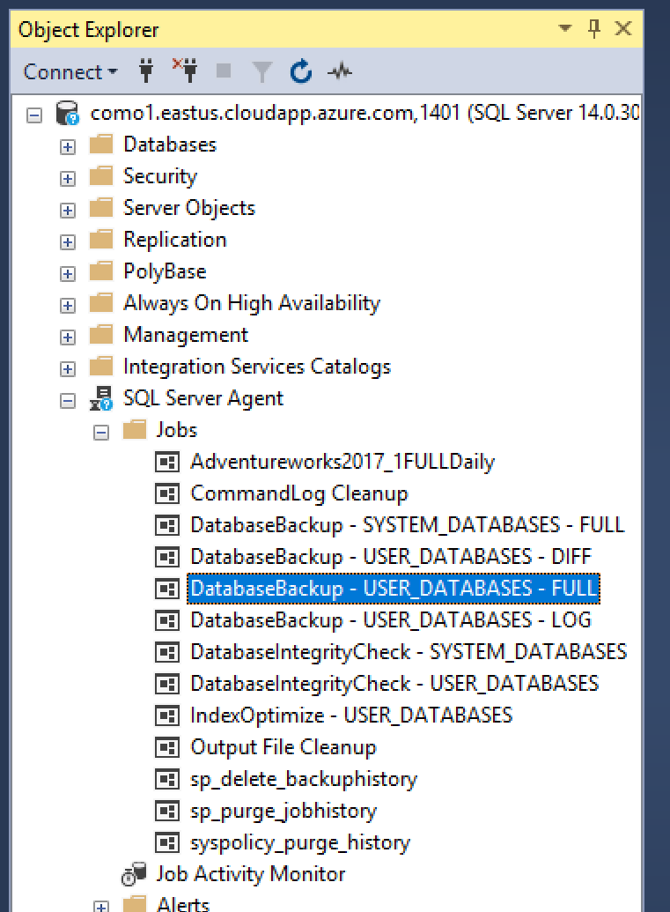

**Step 2:** Enter an easily identifiable name. Usually it goes DatabaseName_ScheduleOfBackup_TypeOfBackUP

Ex: AdventureWorks2017_1hourly_LOG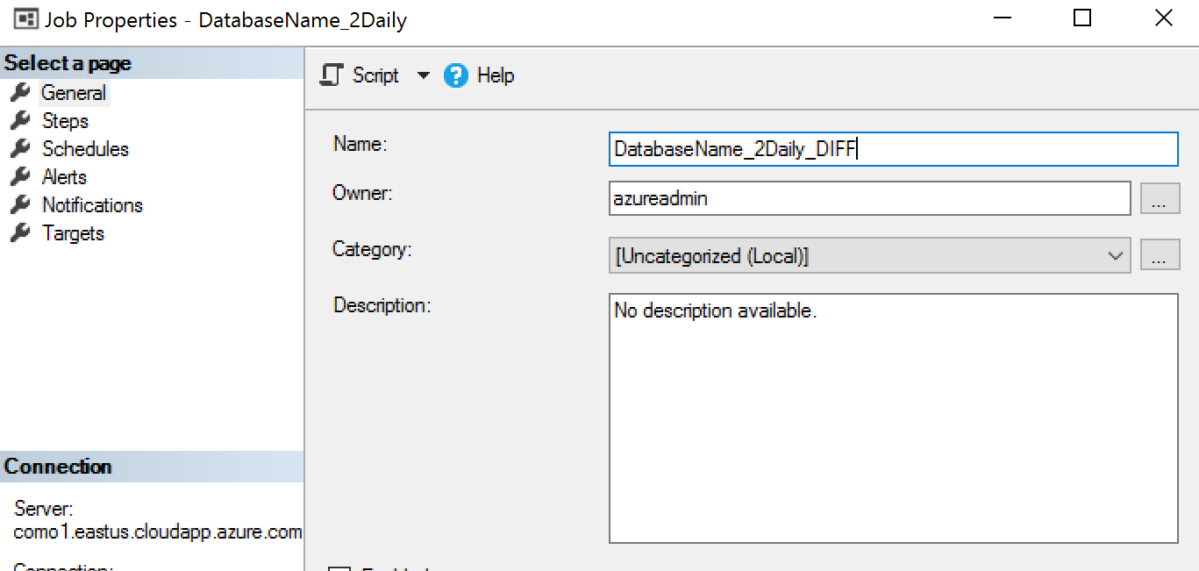

**Step 3:** Navigate to Steps and select new below

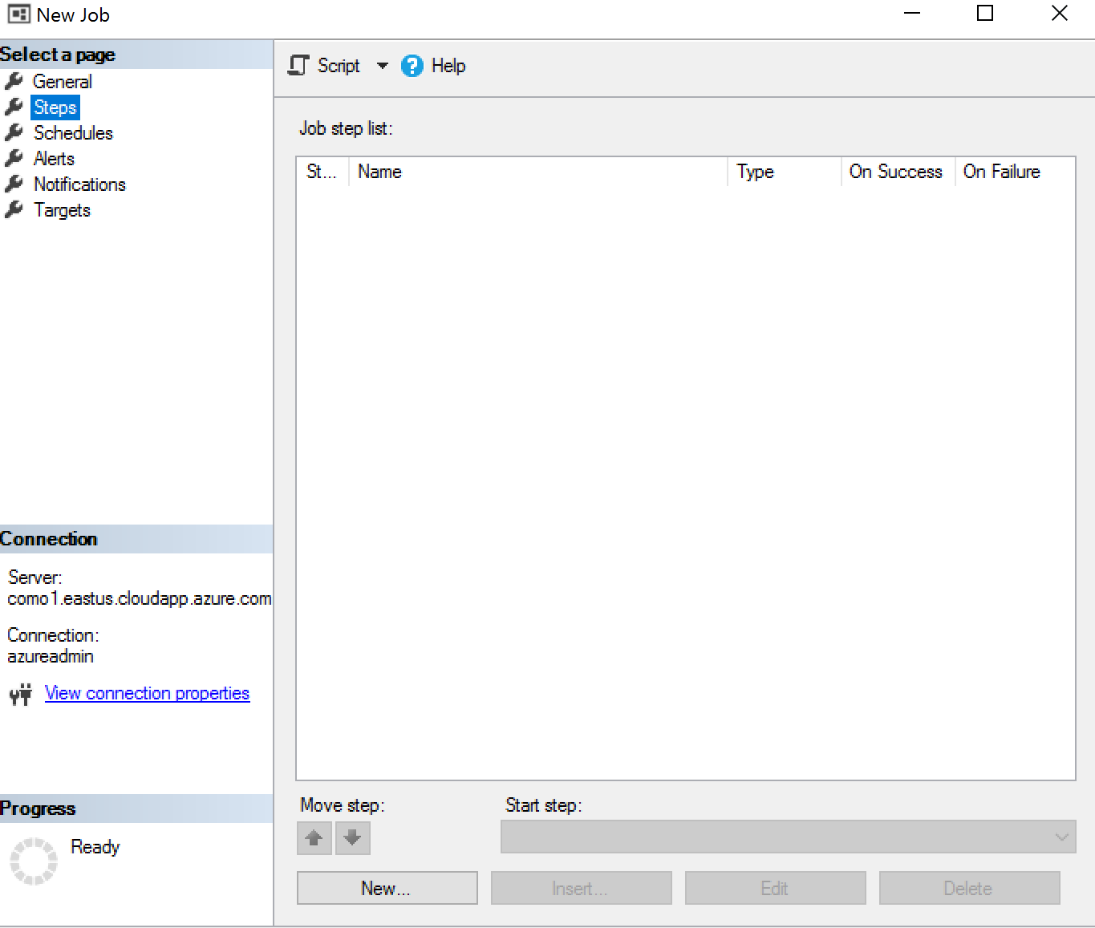

**Step 4:**

Here is the code to place in the step:

EXECUTE [dbo].[DatabaseBackup]

@Databases = 'AdventureWorks2017', --REPLACE WITH YOUR DATABASE NAME

@Directory = N'C:\Program Files\Microsoft SQL Server\Backups',

@BackupType = 'DIFF',

@Verify = 'Y',

@CleanupTime = 48,

@CheckSum = 'Y',

@LogToTable = 'Y'

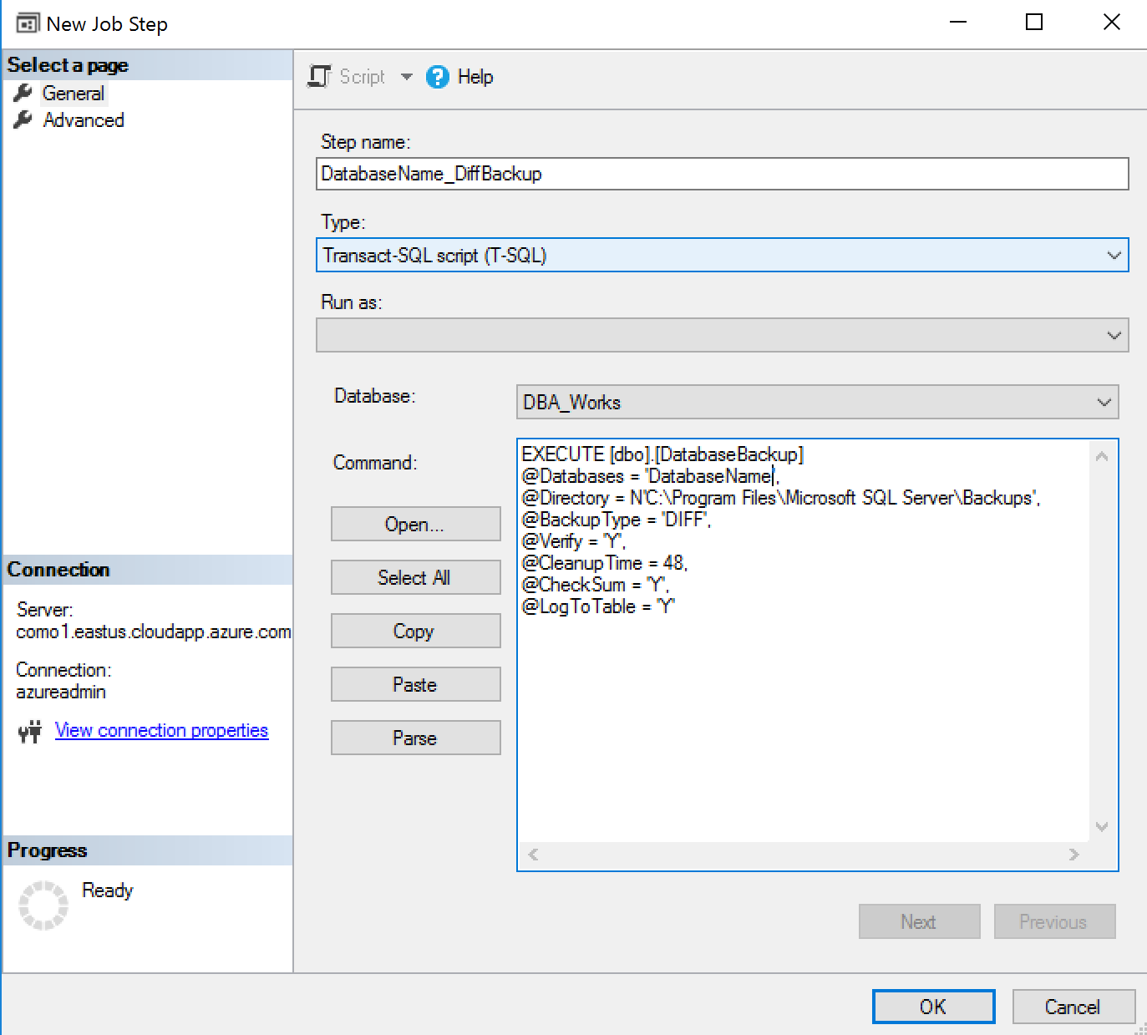

**Note make sure DBA_Works is selected on the drop down. This is where the stored procedure is being called from**

Select OK when finished

**Step 5:** Navigate to Schedules and select new.

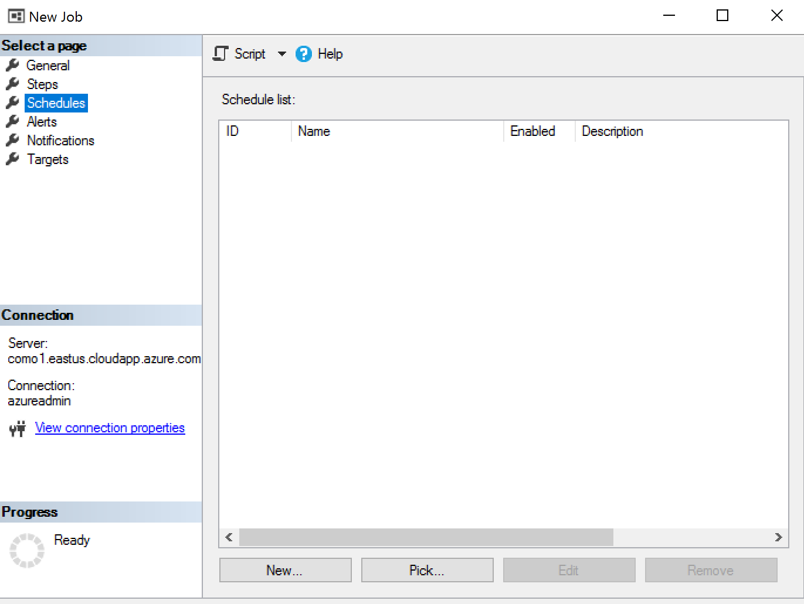

**Step 6:** This is where you will set the frequency and time of the backup. Select ok when finished.

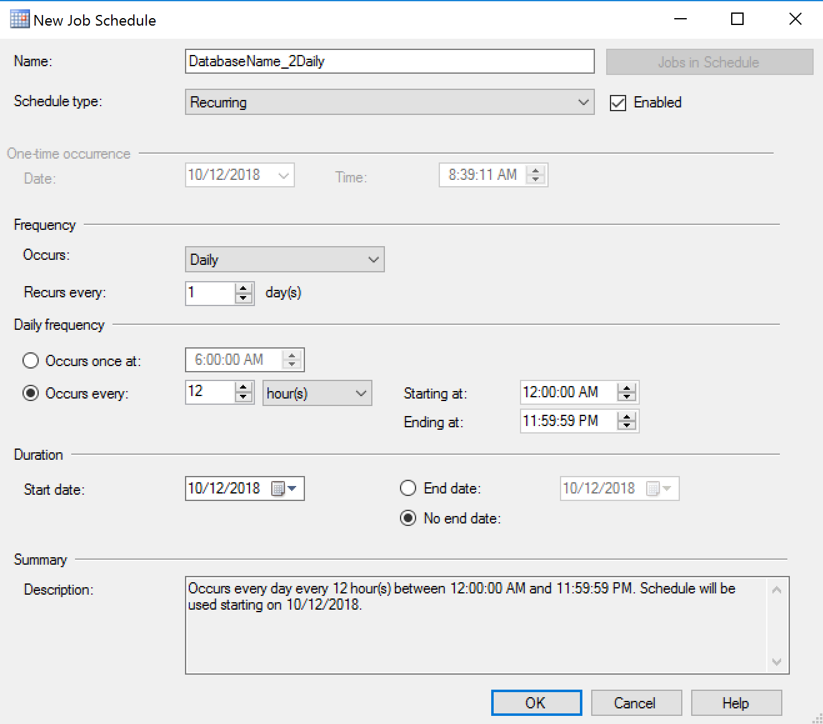

**Step 7:** Select OK again at the button and that’s it! It will appear in the jobs after it is created.

